Естимація. Практика створення тестової документації

Завдання 1. Створи високорівневий тест-кейс для перевірки функціоналу мобільного застосунка (наприклад, Дія або МоноБанк).
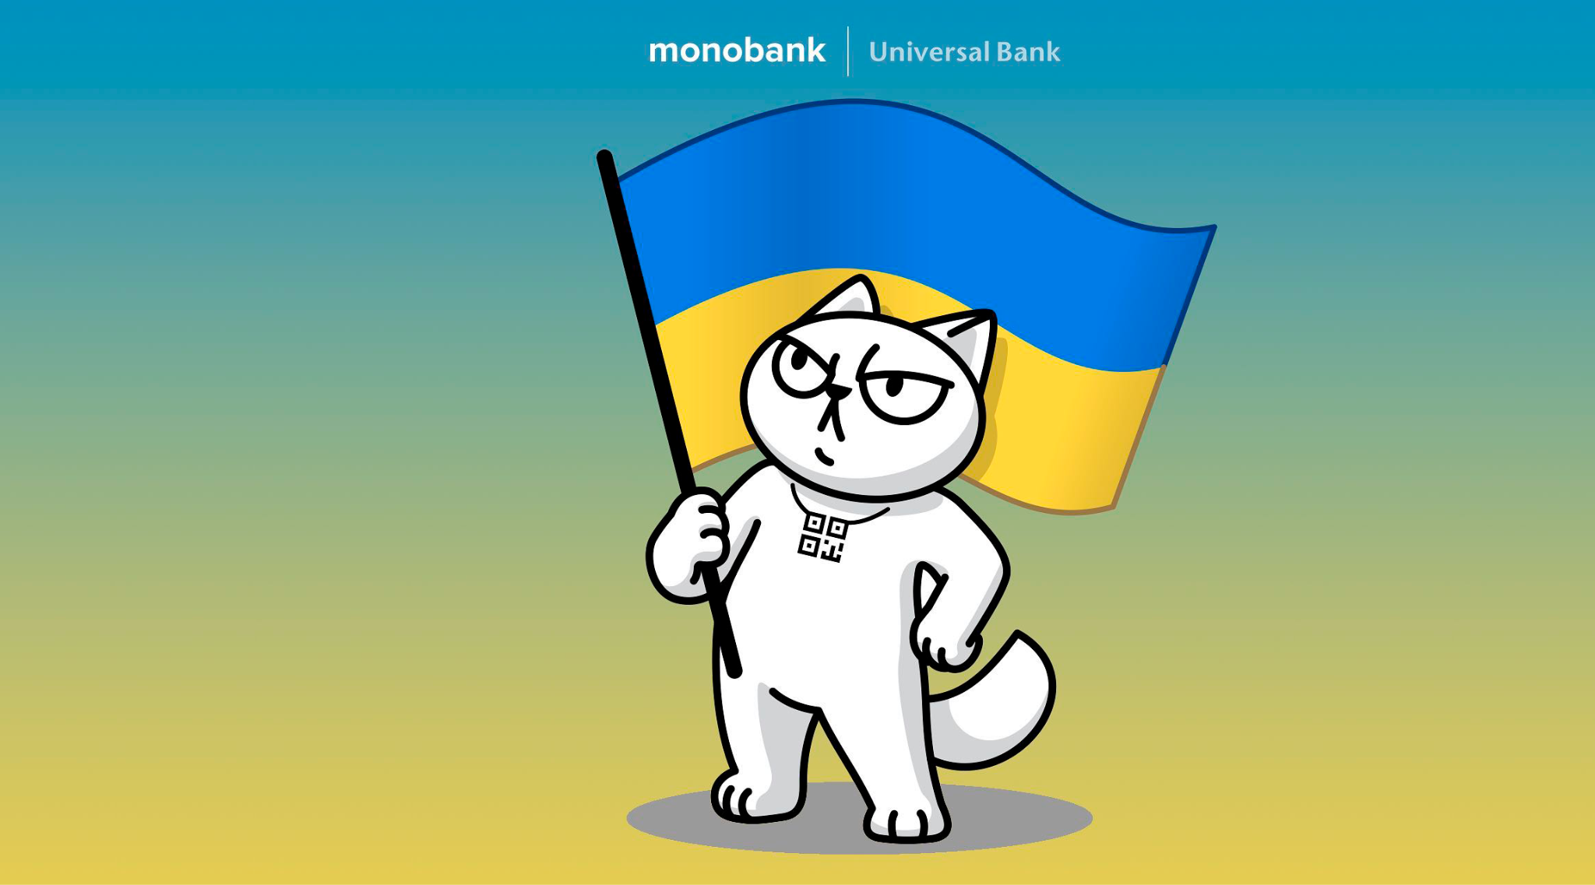
Test Case ID: TC_01
Title: Verify money transfer to another card
Preconditions: The user is logged in to the Monobank application and has a sufficient amount of money in the account.
Steps:
- Open the money transfer feature.
- Enter the recipient’s card details.
- Enter the transfer amount.
- Confirm the transfer.
Expected Result: The transfer is completed successfully. The specified amount is deducted from the user’s account and credited to the recipient’s card. The transaction is displayed in the transaction history.
Завдання 2. Створи 3 низькорівневі тест-кейси на основі високорівневого.

Test Case ID: TC_01.1
Title: Verify money transfer to a card of another bank
Preconditions: The user is logged in to the Monobank application and has a sufficient amount of money in the account.
Steps:
- Open the money transfer feature.
- Enter a valid card number issued by another bank.
- Enter the transfer amount.
- Confirm the transfer.
Expected Result: The transfer is completed successfully. The specified amount is deducted from the user’s account and credited to the recipient’s card. The transaction is displayed in the transaction history.
Test Case ID: TC_01.2
Title: Verify money transfer with insufficient balance
Preconditions: The user is logged in to the Monobank application and has money in the account.
Steps:
- Open the money transfer feature.
- Enter a valid recipient’s card number.
- Enter an amount greater than the available balance.
- Confirm the transfer.
Expected Result: The transfer is not completed. The application displays a message about insufficient funds. No money is deducted from the user’s account.
Test Case ID: TC_01.3
Title: Verify money transfer with an invalid recipient’s card number
Preconditions: The user is logged in to the Monobank application.
Steps:
- Open the money transfer feature.
- Enter an invalid recipient’s card number.
Expected Result: The application displays the message “Неправильний номер картки”.
Завдання 3-4. Проестимуй, скільки часу знадобиться для виконання тест-кейсів з попереднього завдання. Для оцінки використай як мінімум 2 техніки (наприклад, WBS та трьохточкову естимацію).
To estimate the time needed to execute the test cases, I used two estimation techniques: Experience Based Estimation and Story Points.
1. Experience Based Estimation
Based on my previous experience with the Monobank application, I estimated the execution time for each test case:
Test Case: TC_01
Estimated Time: 3 min
Test Case: TC_01.1
Estimated Time: 2 min
Test Case: TC_01.2
Estimated Time: 2 min
Test Case: TC_01.3
Estimated Time: 1 min
Total Estimated Time: 8 min
2. Story Points
I used the simplest test case, TC_01.3, as a reference and gave it 1 Story Point. Then I compared the other test cases with it:
Test Case: TC_01
Story Points: 3 SP
Test Case: TC_01.1
Story Points: 2 SP
Test Case: TC_01.2
Story Points: 2 SP
Test Case: TC_01.3
Story Points: 1 SP
Total: 8 SP

